Plasma

Plasma transports:
- Antibodies
- Urea
- Hormones
- CO₂
- Heat

Blood is 55% plasma, and plasma is 95% water.

Water

Water is a dipole molecule, meaning that there is a slight positive charge on the hydrogens, and a slight negative charge on the oxygen.

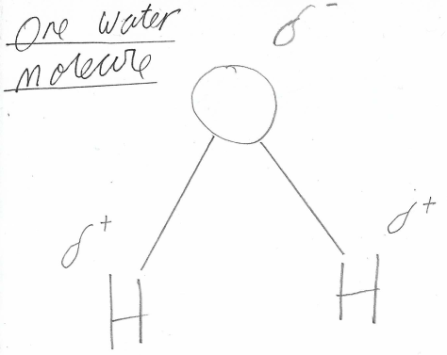

This means water is a very good solvent. The positive side of the water is attracted to negative ions, and the negative side of the water is attracted to the positive ions.

When the water molecules surround an ion, the ion is considered dissolved.

Dissolved substances are much more easily moved by the body, so the blood is made up of water for better transport.

Being a dipole molecule also means that water molecules are attracted to each other, meaning that they flow easily, and are very good for mass flow in the body.

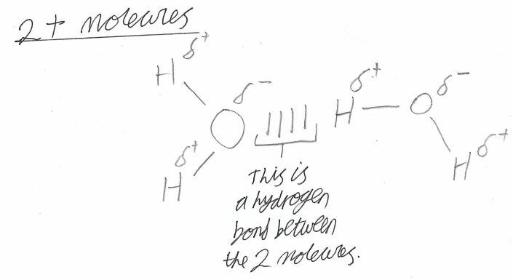
Water warms and cools fairly slowly, as lots of energy is needed to break the hydrogen bonds between water molecules. This means that rapid heating/cooling is slowed in the body, and so our bodies can keep their temperature more constant.

